

**YILDIZ TEKNİK ÜNİVERSİTESİ**

**KİMYA-METALÜRJİ FAKÜLTESİ**

**MATEMATİK MÜHENDİSLİĞİ**

**MATEMATİK MÜHENDİSLİĞİNDE TASARIM UYGULAMALARI**

**Social Media Application Using Firebase and Android Studio**

Advisor: Öğr. Gör. Dr. Gökhan GÖKSU

Şaban Çepni

17058052

CONTENT

**1. INTRODUCTION.......................................................................................................................................3**

**2. FIREBASE...................................................................................................................................................3**

**2.1. History of Firebase...................................................................................................................................3**

**2.2. Benefits......................................................................................................................................................3**

**2.3. Firebase Vs Other Database Applications.............................................................................................4**

**3. FIREBASE FEATURES**

**3.1. Firebase Authentication...........................................................................................................................4**

**3.2. Firebase Cloud Messaging (FCM) .........................................................................................................4- 5**

**3.3. Firebase Storage.......................................................................................................................................5**

**3.4. Firebase Analytics....................................................................................................................................5**

**3.5. Firebase Database....................................................................................................................................5**

**4. CONCLUSION..........................................................................................................................................6**

**5. WORK FLOW DIAGRAM OF THE APPLICATION……………………………………………….6**

**6. APPLICATION INTERFACES AND CODES......................................................................................7**

**6.1. Main Screen ............................................................................................................................................7**

**6.2. Signup ....................................................................................................................................................8- 9**

**6.3. Login .......................................................................................................................................................10**

**6.4. Home Page .............................................................................................................................................11**

**6.5. Home Page Search .................................................................................................................................12- 14**

**6.6. Profile Page ............................................................................................................................................15**

**6.7. Profile Page Edit ...................................................................................................................................16- 17**

**6.8. Profile Picture Select ............................................................................................................................18**

**6.9. Toolbar Menu.........................................................................................................................................19**

**6.10. Userlist Menu........................................................................................................................................20**

**6.11. Userlist Menu Interaction ...................................................................................................................21**

**6.12. Other Person Profile ............................................................................................................................22**

**6.13. Post Details And Comments ................................................................................................................23- 24**

**6.14. Notifications...........................................................................................................................................25**

**6.15. Chat List ................................................................................................................................................26- 27**

**6.16. Post Add.................................................................................................................................................28- 29**

**6.17. Chat.........................................................................................................................................................30**

**6.18. Chat last seen..........................................................................................................................................31**

**7. REFERENCES ...........................................................................................................................................32**

**1. INTRODUCTION**

Firebase is very easy to use and very performance focused database application and i wanted to make social media application without focusing on database side for my personal use.

**2. FIREBASE**

Firebase is a google’s mobile app development platform that has a huge toolset that contains lots of things for improving,scaling and creating your android application. Analytics, authentication, databases, configuration, file storage, push messaging, and so on are all examples. The services are hosted in the cloud and can scale with little to no effort on the developer's part.

**2.1. History of Firebase**

Envolve, a previous firm established in 2011 by James Tamplin and Andrew Lee, gave rise to Firebase. Tamplin and Lee discovered that application data other than chat messages were being passed through the chat service after it had been made available. They made the decision to divide the chat system's real-time architecture. In 2011, they established Firebase as a distinct business, and in April 2012, they made it available to the public.

**2.2. Benefits**

If you don't want to waste time learning databases or don't want to create database-related code because you have little to no experience with them. You don't require any middleware between your app and the service because Firebase's client SDKs communicate directly with these backend services. You normally write code to query the database in your client app if you're utilizing one of the Firebase database choices. Its that easy to use.

**2.3. Firebase vs Other Database Applications**

Firebase uses the JavaScript Object Notation (JSON) format to store its data, which eliminates the need for queries when inserting, updating, deleting, or adding data. Oracle SQL, Microsoft SQL Server, and MySQL are the servers used for Android apps, and they are linked to the server via PHP files. The other servers store data in a table (rows and columns) format.

Firebase is a NoSQL database. There are very few cloud-based servers that are similar to firebase, which makes firebase stand out.

While Firebase (and NoSQL databases in general) make it challenging to define relationships between data and maintain consistency across duplicate data, once you figure that out, scaling that database is fairly straightforward.

Despite SQL databases may never need duplicate data and make it simple to express links between data, they are highly challenging to scale if you run a lot of queries that depend on figuring out those relationships at the time of the query (with table joins). Conclusion it can be advantageous to choose one over the other depending on the product.

**3. FIREBASE FEATURES**

**3.1. Firebase Authentication**

Firebase Authentication handles logging in and identifying your users. What makes Firebase Authentication unique is that it makes it simple to perform secure logins, which are extremely difficult to implement correctly on your own. It is a service that only requires client-side code to authenticate users. Firebase Auth is compatible with social login providers such as Facebook, Google GitHub, and Twitter. If you are using android studio just one click at the firebase authentication adds all necessarry SDK’s.

**3.2. Firebase Cloud Messaging (FCM)**

It was previously known as Google Cloud Messaging. Firebase Authentication handles logging in and identifying your users. What makes Firebase Authentication unique is that it makes it simple to perform secure logins, which are extremely difficult to implement correctly on your own. It is a service that only requires client-side code to authenticate users. Firebase Auth is compatible with social login providers such as Facebook, Google GitHub, and Twitter. If you are using android studio just one click at the firebase authentication adds all necessarry SDK’s.

**3.3. Firebase Storage**

Cloud Storage is a massively scalable file storage solution. It is, technically, a Google Cloud product rather than a Firebase product. You get client SDKs for your app that allow you to upload and download files directly to and from your Cloud Storage "bucket" with Cloud Storage for Firebase. It enables easy and secure file transfer for Firebase apps regardless of network quality. In addition, the developer can use it to store images, audio, video, or other user-generated content.

**3.4. Firebase Analytics**

Firebase Analytics uses the most used analytics app Googles Analytics. This feature allows the application developer to understand how users interact with the application. The SDK includes the ability to capture events and characteristics on its own, as well as obtain custom data.

**3.5. Firebase Database**

Firebase offers services such as a real-time database and a backend. The Firebase Realtime Database is a database that is hosted in the cloud. Data is stored as JSON and is synchronized in realtime to every client that is connected. The application developer is given an API that allows application data to be synchronized among clients and stored on Firebase's cloud. Firebase's real-time database capability is extremely simple to utilize. Unstructured data can be readily added to the database once the Firebase and database requirements are introduced to the program.

**4. CONCLUSION**

There isnt a fixed tool for authentication, cloud messaging, analytics, database and storage if you want to use you’ll pick the one that suits most in your case. When you want to focus on the app more instead of these tools Firebase is one of the most pickable one. I picked Firebase cause i have limited time, im working alone and i’m new to android development its my first app i wanted to focus on mostly application instead of database side.

**5. WORK FLOW DIAGRAM OF THE APPLICATION**

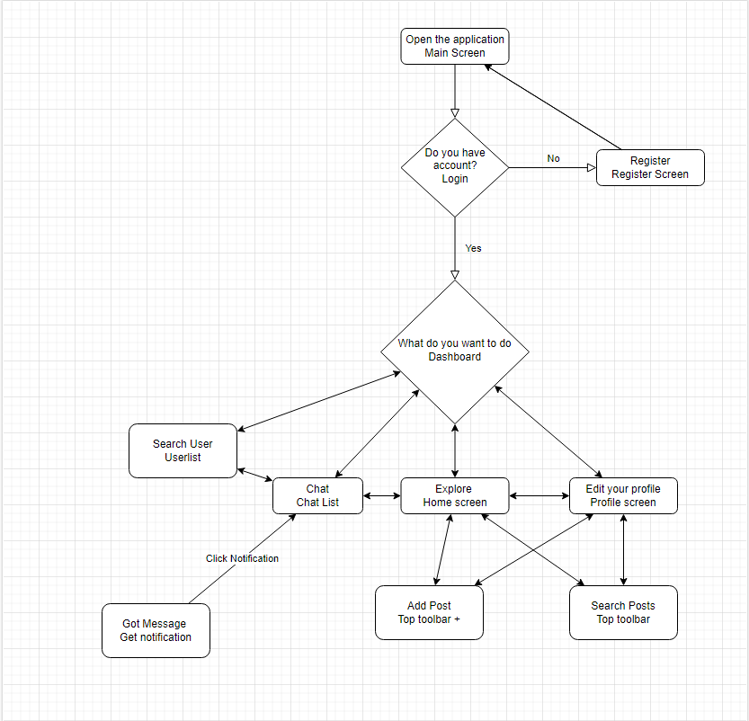

**6. APPLICATION INTERFACES AND CODES**

Note that every picture is a working screenshot of the application.

**6.1. Main Screen**

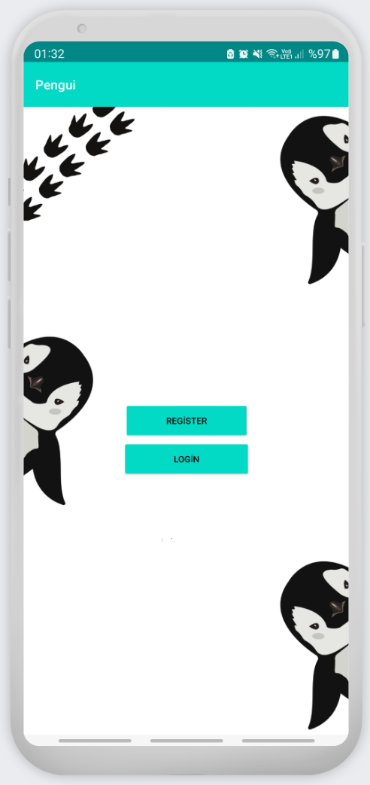

**6.2. Signup**

metin içeren bir resim

Açıklama otomatik olarak oluşturuldu

**Register Page Authentication Code:**

private void registerUser(String email, String password, String name) {  
 //email and password pattern is valid, show progress dialog and start registering user  
 progressDialog.show();  
 mAuth.createUserWithEmailAndPassword(email, password)  
 .addOnCompleteListener(this, new OnCompleteListener<AuthResult>() {  
 @Override  
 public void onComplete(@NonNull Task<AuthResult> task) {  
 if (task.isSuccessful()){  
 //Sign in success, dismiss dialog and start register activity  
 progressDialog.dismiss();  
  
 FirebaseUser user = mAuth.getCurrentUser();  
 //get user email and uid from auth  
 String email = user.getEmail();  
 String uid = user.getUid();  
 //When user is registered store user info in firebase realtime database too  
 // using HashMap  
 HashMap<Object, String> hashMap = new HashMap<>();  
 //put info in hashmap  
 hashMap.put("email", email);  
 hashMap.put("uid", uid);  
 hashMap.put("name", name); //isnt complete yet  
 hashMap.put("onlineStatus", "online");  
 hashMap.put("typingTo", "noOne");  
 hashMap.put("phone", "");  
 hashMap.put("image", "");  
 hashMap.put("cover", "");  
  
 //firebase database instance  
 FirebaseDatabase database = FirebaseDatabase.*getInstance*();  
 //path to store user data named "Users"  
 DatabaseReference reference = database.getReference("Users");  
 //put data within hashmap  
 reference.child(uid).setValue(hashMap);

**6.3. Login Page**

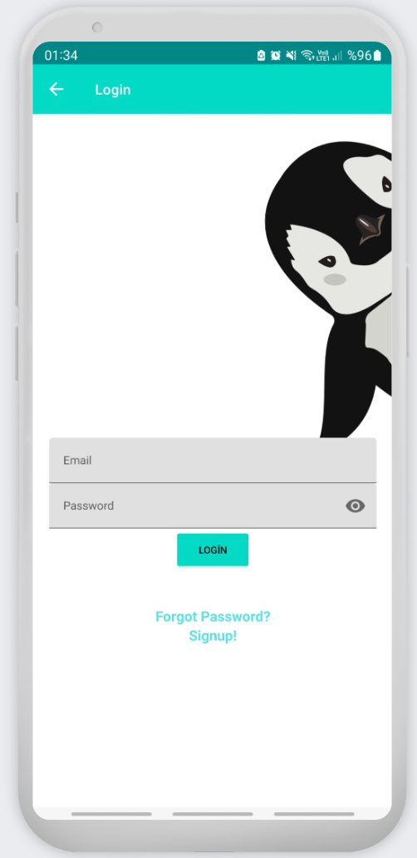

**6.4. Home Page**

metin içeren bir resim

Açıklama otomatik olarak oluşturuldu

**6.5. Home Page Search**

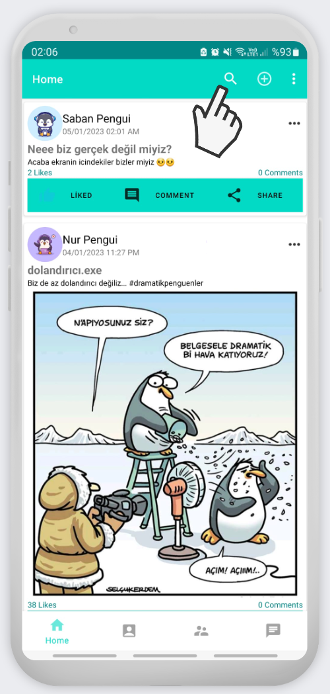

**Home Page Search Code:**

private void searchPosts(String searchQuery){  
//path of all posts  
 DatabaseReference ref = FirebaseDatabase.*getInstance*().getReference("Posts");  
 //get all data from ref  
 ref.addValueEventListener(new ValueEventListener() {  
 @Override  
 public void onDataChange(@NonNull DataSnapshot snapshot) {  
 postList.clear();  
 for (DataSnapshot ds: snapshot.getChildren()){  
 ModelPost modelPost = ds.getValue(ModelPost.class);  
  
 if(modelPost.getpTitle().toLowerCase(Locale.*ROOT*).contains(searchQuery.toLowerCase(Locale.*ROOT*))||  
 modelPost.getpDescr().toLowerCase(Locale.*ROOT*).contains(searchQuery.toLowerCase(Locale.*ROOT*))){  
 postList.add(modelPost);  
 }  
  
  
 //adapter  
 adapterPosts = new AdapterPosts(getActivity(),postList);  
 //set adapter to recycle view  
 recyclerView.setAdapter(adapterPosts);  
 }  
 }  
  
 @Override  
 public void onCancelled(@NonNull DatabaseError error) {  
 Toast.*makeText*(getActivity(), ""+error.getMessage(), Toast.*LENGTH_SHORT*).show();  
 }  
 });  
  
 }

metin içeren bir resim

Açıklama otomatik olarak oluşturuldu

*Clicking search button open text view that user can type.*

**6.6. Profile Page**

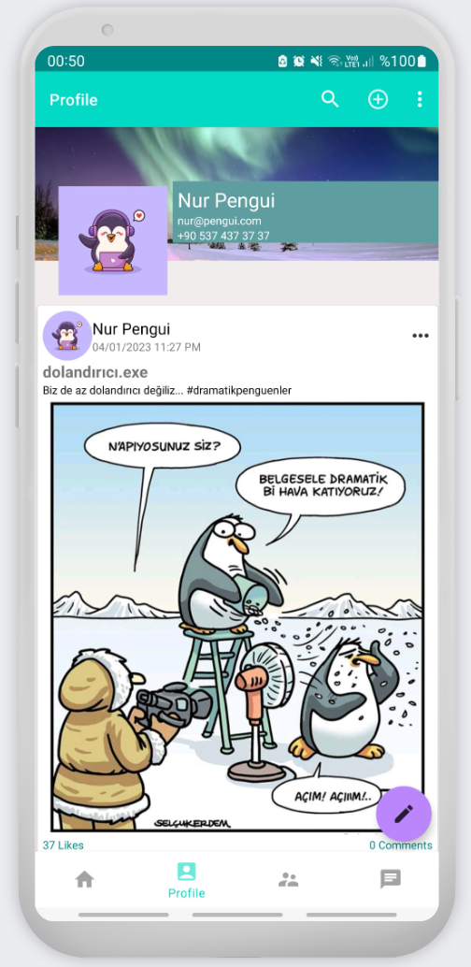

**6.7. Profile Page Edit**

metin içeren bir resim

Açıklama otomatik olarak oluşturuldu

**Profile Page Edit Tool Code:**

private void showEditProfileDialog() {  
 //options to show in dialog  
 String options[] = {"Edit Profile Picture","Edit Cover Photo","Edit Name","Edit Phone"};  
 //alert dialog  
 AlertDialog.Builder builder = new AlertDialog.Builder(getActivity());  
 //set title  
 builder.setTitle(("Choose Action"));  
 //set items to dialog  
 builder.setItems(options, new DialogInterface.OnClickListener() {  
 @Override  
 public void onClick(DialogInterface dialog, int which) {  
 //handle dialog item clicks  
 if (which == 0 ){  
 //Edit Profile Picture  
 pd.setMessage("Updating Profile Picture");  
 profileOrCoverPhoto = "image"; //i.e. changing profile picture, make sure to assign same value  
 showImagePicDialog();  
 }  
 else if (which == 1){  
 //Edit Cover Photo  
 pd.setMessage("Updating Cover Picture");  
 profileOrCoverPhoto = "cover"; //i.e. changing cover photo, make sure to assign same value  
 showImagePicDialog();  
 }  
 else if (which == 2){  
 //Edit Name  
 pd.setMessage("Updating Name");  
 //calling method and pass key name as paramter to update itsvalue in database  
 showNamePhoneUpdateDialog("name");  
 }  
 else if (which == 3){  
 //Edit Phone  
 pd.setMessage("Updating Phone Number");  
 showNamePhoneUpdateDialog("phone");  
 }  
 }  
 });  
 builder.create().show();  
}

**6.8. Profile Page Picture Select**

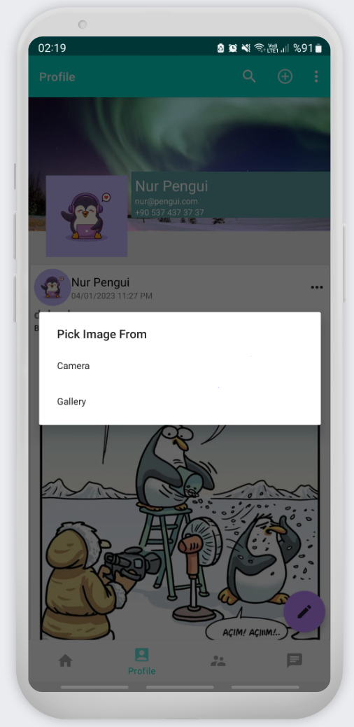

**6.9. Toolbar Menu**



**6.10. Userlist Menu**

metin içeren bir resim

Açıklama otomatik olarak oluşturuldu

**6.11. Userlist Menu Interaction**

metin içeren bir resim

Açıklama otomatik olarak oluşturuldu

**6.12. Other Persons Profile**

metin içeren bir resim

Açıklama otomatik olarak oluşturuldu

**6.13. Post Details and Comments**

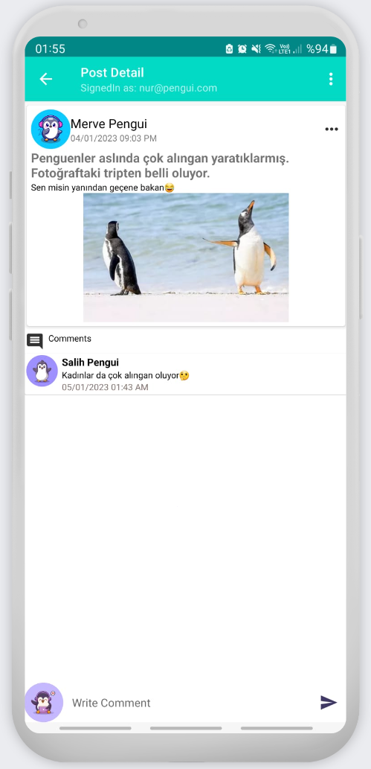

**Post Loading Info Code:**

private void loadPostInfo() {  
 //get post using id of the post  
 DatabaseReference ref = FirebaseDatabase.*getInstance*().getReference("Posts");  
 Query query = ref.orderByChild("pId").equalTo(postId);  
 query.addValueEventListener(new ValueEventListener() {  
 @Override  
 public void onDataChange(@NonNull DataSnapshot snapshot) {  
 for (DataSnapshot ds: snapshot.getChildren()){  
 //get data  
 String pTitle = ""+ds.child("pTitle").getValue();  
 String pDescr = ""+ds.child("pDescr").getValue();  
 pLikes = ""+ds.child("pLikes").getValue();  
 String pTimeStamp = ""+ds.child("pTime").getValue();  
 pImage = ""+ds.child("pImage").getValue();  
 hisDp = ""+ds.child("uDp").getValue();  
 hisUid = ""+ds.child("uid").getValue();  
 String uEmail = ""+ds.child("uEmail").getValue();  
 hisName = ""+ds.child("uName").getValue();  
 String commentCount = ""+ds.child("pComments").getValue();  
  
 //timestamp convert  
 Calendar calendar = Calendar.*getInstance*(Locale.*getDefault*());  
 calendar.setTimeInMillis(Long.*parseLong*(pTimeStamp));  
 String pTime = DateFormat.*format*("dd/MM/yyyy hh:mm aa",calendar).toString();  
  
 //set data in view  
 pTitleTv.setText(pTitle);  
 pDescriptionTv.setText(pDescr);  
 pLikesTv.setText(pLikes+" Likes");  
 pTimeTv.setText(pTime);  
 pCommentsTv.setText(commentCount+" Comments");  
  
 uNameTv.setText(hisName);

**6.14. Notifications**

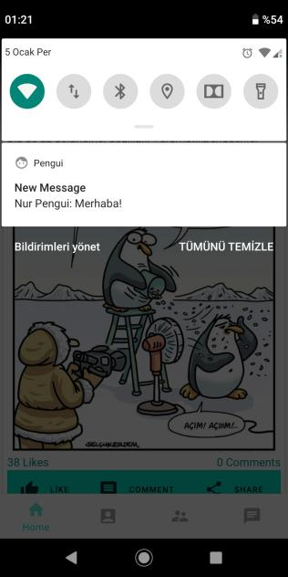

**6.15. Chat List**

metin içeren bir resim

Açıklama otomatik olarak oluşturuldu

**Chat List Code:**

private void loadChats() {  
 userList = new ArrayList<>();  
 reference = FirebaseDatabase.*getInstance*().getReference("Users");  
 reference.addValueEventListener(new ValueEventListener() {  
 @Override  
 public void onDataChange(@NonNull DataSnapshot snapshot) {  
 userList.clear();  
 for (DataSnapshot ds: snapshot.getChildren()){  
 ModelUser user = ds.getValue(ModelUser.class);  
 for(ModelChatlist chatlist: chatlistList){  
 if(user.getUid() != null && user.getUid().equals(chatlist.getId())){  
 userList.add(user);  
 break;  
 }  
 }  
 //adapter  
 adapterChatlist = new AdapterChatlist(getContext(),userList);  
 //setadapter  
 recyclerView.setAdapter(adapterChatlist);  
 //set last message  
 for(int i=0;i<userList.size();i++){  
 lastMessage(userList.get(i).getUid());  
 }  
 }  
 }

**6.16. Post Add Page**

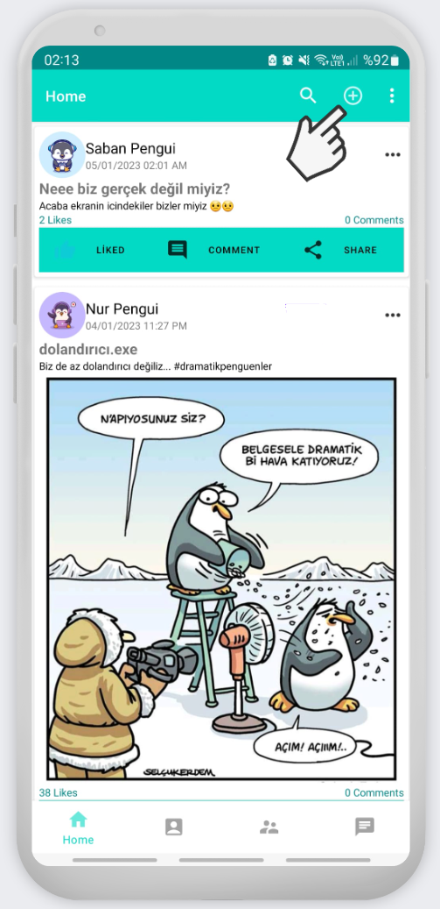

*Clicking the plus button opens up a new add post view.*

metin içeren bir resim

Açıklama otomatik olarak oluşturuldu

**6.17. Chat**

metin içeren bir resim

Açıklama otomatik olarak oluşturuldu

**6.18. Chat Last Seen**

metin içeren bir resim

Açıklama otomatik olarak oluşturuldu

**7. REFERENCES**

* 1. Khawas, C., & Shah, P. (2018). Application of firebase in android app development-a study. *International Journal of Computer Applications*, *179*(46), 49-53.
  2. Moroney, L. (2017). An Introduction to Firebase. In *The Definitive Guide to Firebase* (pp. 1-24). Apress, Berkeley, CA.
  3. Shukla, S., Gupta, S. C., & Mishra, P. (2021, January). Android-Based Chat Application Using Firebase. In *2021 International Conference on Computer Communication and Informatics (ICCCI)* (pp. 1-4). IEEE.
  4. Kumar, A. (2018). *Mastering Firebase for Android Development: Build real-time, scalable, and cloud-enabled Android apps with Firebase*. Packt Publishing Ltd.
  5. Chatterjee, N., Chakraborty, S., Decosta, A., & Nath, A. (2018). Real-time communication application based on android using Google firebase. *Int. J. Adv. Res. Comput. Sci. Manag. Stud*, *6*
  6. <https://medium.com/firebase-developers/what-is-firebase-the-complete-story-abridged-bcc730c5f2c0>